Japanese American Internment

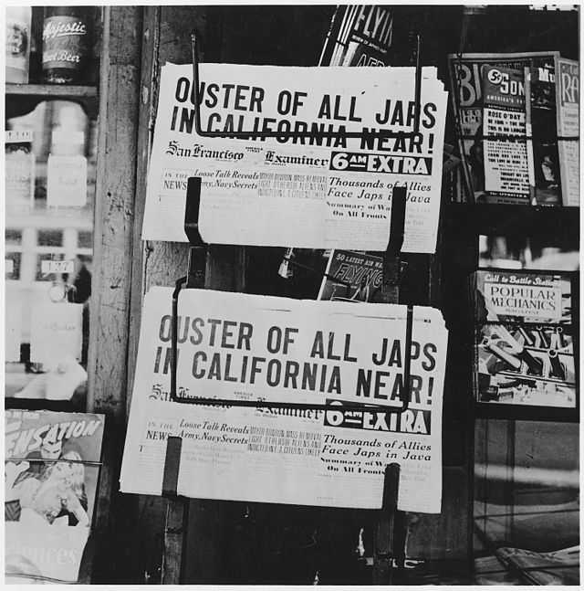

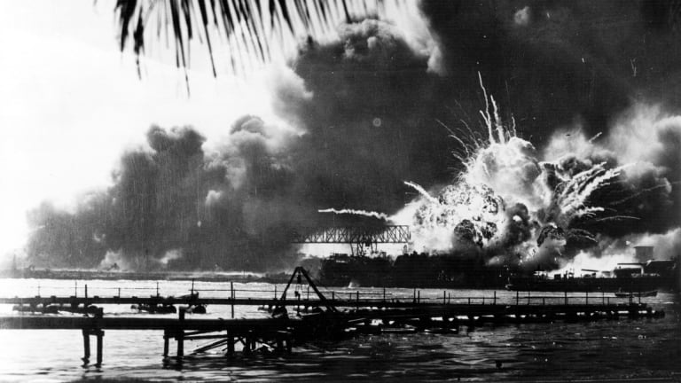

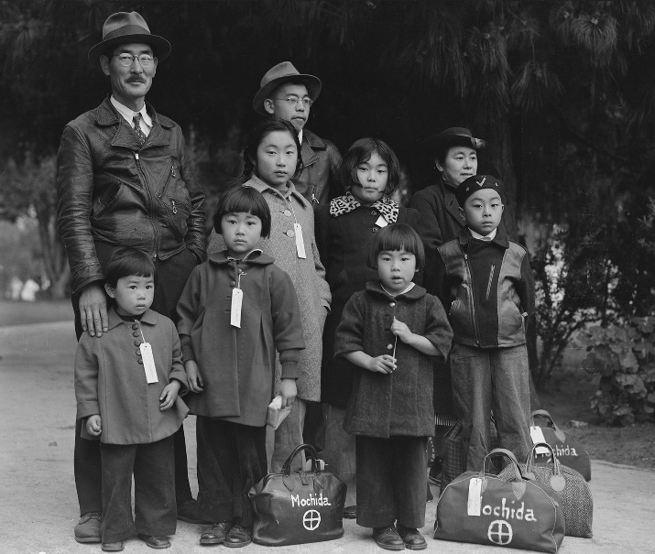

Document Based Questions
Document 1: Admiral Osami Nagano, Japan, September 6, 1941

“From the standpoint of the Imperial General Headquarters, based on the assumption that a peaceful solution has not been found and war is inevitable, the Empire’s oil supply, as well as the stockpiles of many other important war materials, is decreasing day by day with the result that the national defense power is gradually diminishing. If this deplorable situation is left unchecked, I believe that, after a lapse of some time, the nation’s vitality will deteriorate and ultimately fall into dire straits.”
--Admiral Osami Nagano, Tokyo, Japan, September 6, 1941

- What is your interpretation of the text? Support your response.
______________________________________________________________________________
______________________________________________________________________________
______________________________________________________________________________

- What does the text tell us about the time and place of its creation?
______________________________________________________________________________
______________________________________________________________________________
______________________________________________________________________________

- Can you elaborate on the reason that Japan’s oil and war supplies are decreasing so rapidly?
______________________________________________________________________________
______________________________________________________________________________
______________________________________________________________________________

- Can you formulate a theory as to what Japan might do next? Support your response.
______________________________________________________________________________
______________________________________________________________________________
______________________________________________________________________________

Document 2: Executive Order No. 9066

Executive Order No. 9066
The President
Executive Order
Authorizing the Secretary of War to Prescribe Military Areas

“….Now, therefore, by virtue of the authority vested in me as President of the United States, and Commander in Chief of the Army and Navy, I hereby authorize and direct the Secretary of War, and the Military Commanders whom he may from time to time designate, whenever he or any designated Commander deems such action necessary or desirable, to prescribe military areas in such places and of such extent as he or the appropriate Military Commander may determine, from which any or all persons may be excluded, and with respect to which, the right of any person to enter, remain in, or leave shall be subject to whatever restrictions the Secretary of War or the appropriate Military Commander may impose in his discretion.”

- What is your interpretation of the text? Support your response.
______________________________________________________________________________
______________________________________________________________________________
______________________________________________________________________________

- What circumstances influenced the creation of this text?
______________________________________________________________________________
______________________________________________________________________________
______________________________________________________________________________

- What group of people will be primarily targeted by this Executive Order? Refer back to Document 1 for help.
______________________________________________________________________________
______________________________________________________________________________
______________________________________________________________________________

- Do you agree or disagree with the enforcement of Executive Order No. 9066? Explain your response.
______________________________________________________________________________
______________________________________________________________________________
______________________________________________________________________________

Document 3: Western Defense Command and Fourth Army Wartime Civil Control Administration flyer.

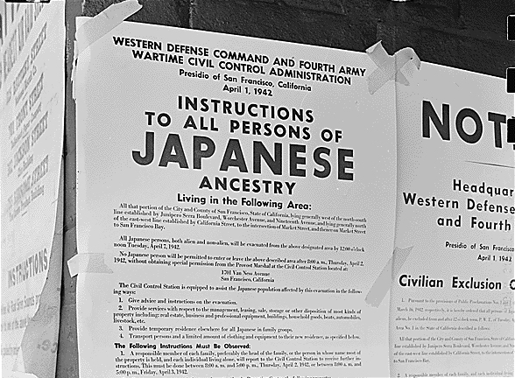

- What event(s) led to the creation of this flyer?
______________________________________________________________________________
______________________________________________________________________________
______________________________________________________________________________

- How were the rights of Japanese Americans restricted during World War 2?
______________________________________________________________________________
______________________________________________________________________________
______________________________________________________________________________

- How would you test the effectiveness of the Executive Order? Explain.
______________________________________________________________________________
______________________________________________________________________________
______________________________________________________________________________

- Which is more important, National Security, or Civil Liberties? Explain your reasoning.
______________________________________________________________________________
______________________________________________________________________________
______________________________________________________________________________

Document 4: Justice Hugo Black, decision of Korematsu v. United States (1944)

“Korematsu was not excluded from the military area because of hostility to him or his race. He was excluded because we are at war with the Japanese Empire, because the… authorities feared an invasion of our West Coast and felt constrained to take proper security measures.”
--Justice Hugo Black, decision of Korematsu v. United States (1944)

- Based on this excerpt why did the court restrict Korematsu’s rights?
______________________________________________________________________________
______________________________________________________________________________
______________________________________________________________________________

- How fully does this text represent American from 1941-44? Explain.
______________________________________________________________________________
______________________________________________________________________________
______________________________________________________________________________

- What might have been a motivation for Korematsu to try to join the American armed forces?
______________________________________________________________________________
______________________________________________________________________________
______________________________________________________________________________

- What would have happened to Japanese Americans if Japan had not bombed Pearl Harbor? Explain.
______________________________________________________________________________
______________________________________________________________________________
______________________________________________________________________________

